GitHub account :

https://github.com/koustav221b/Hello-BOT.git

For cloning a repository in local desktop:

https://help.github.com/articles/cloning-a-repository/

Open github and go to ur repository:

Clone the url by clicking the "clone or Download' option in github and copy the url

Open git bash and move to the directory where you want the code to be pushed.

git clone https://github.com/Your-Username/Your-Repository

E.g.

git clone https://github.com/koustav221b/Hello-BOT.git

U have to have the .git file in order to run the git commands

Git init – initialized an empty git repository in the local desktop and creates the .git file



git status – shows the status of the file added or commited

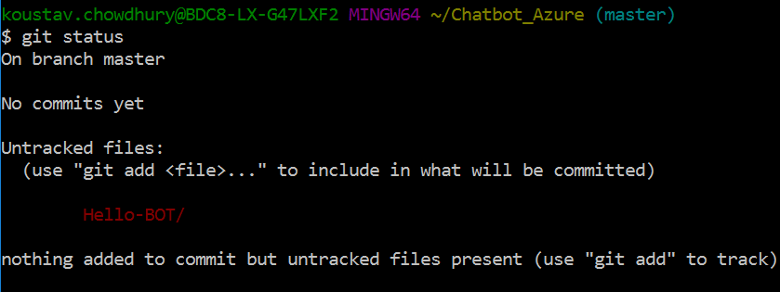

git remote add myGithubRepo <https://github.com/koustav221b/Hello-BOT.git>

associates ‘myGithubRepo’ name to the github url “<https://github.com/koustav221b/Hello-BOT.git>”

git remote – shows the name of the github repo

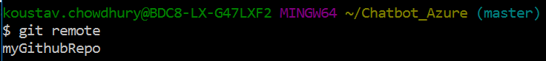

Git Commands:

<https://education.github.com/git-cheat-sheet-education.pdf>

After adding the new files, do

git add – add the files/changes to the staging area

git add Hello-BOT



Then git commit – adds your changes to the local version control database.

git commit -m 'Git tutorials along with Readme'

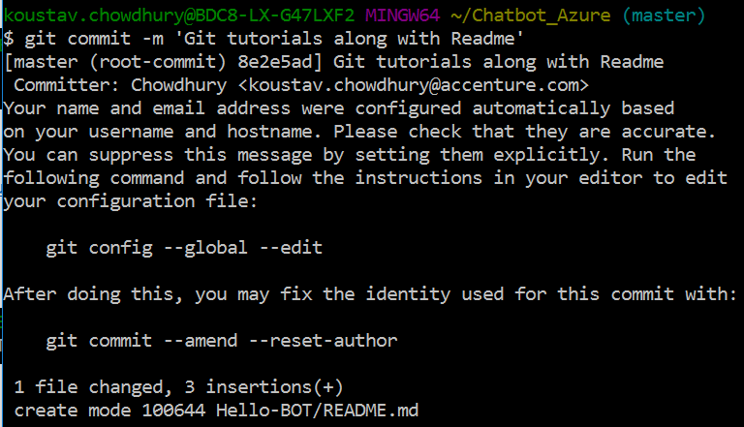

After running ‘git commit’ the changes are still not pushed to remote server.

Git log – shows all the commit history

